Drexel University

MIS 632

Term Project

Omar Cunningham

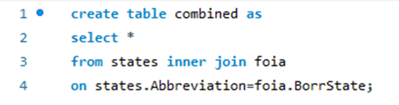

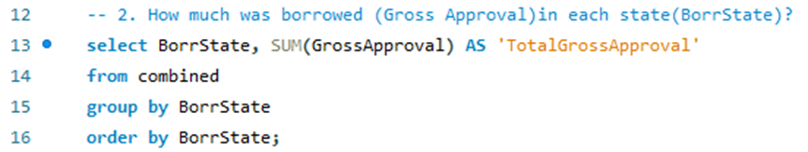

|  |  |
| --- | --- |
| BorrState | NumBorrowers |
| AK | 13 |
| AL | 43 |
| AR | 30 |
| AS | 1 |
| AZ | 96 |
| CA | 533 |
| CO | 127 |
| CT | 50 |
| DC | 3 |
| DE | 9 |
| FL | 170 |
| GA | 127 |
| GU | 7 |
| HI | 30 |
| IA | 81 |
| ID | 83 |
| IL | 161 |
| IN | 104 |
| KS | 42 |
| KY | 50 |
| LA | 63 |
| MA | 159 |
| MD | 66 |
| ME | 61 |
| MI | 154 |
| MN | 156 |
| MO | 106 |
| MS | 79 |
| MT | 48 |
| NC | 102 |
| ND | 40 |
| NE | 44 |
| NH | 65 |
| NJ | 111 |
| NM | 32 |
| NV | 30 |
| NY | 268 |
| OH | 181 |
| OK | 49 |
| OR | 63 |
| PA | 159 |
| PR | 34 |
| RI | 31 |
| SC | 32 |
| SD | 28 |
| TN | 76 |
| TX | 380 |
| UT | 170 |
| VA | 87 |
| VI | 3 |
| VT | 23 |
| WA | 129 |
| WI | 180 |
| WV | 15 |
| WY | 15 |

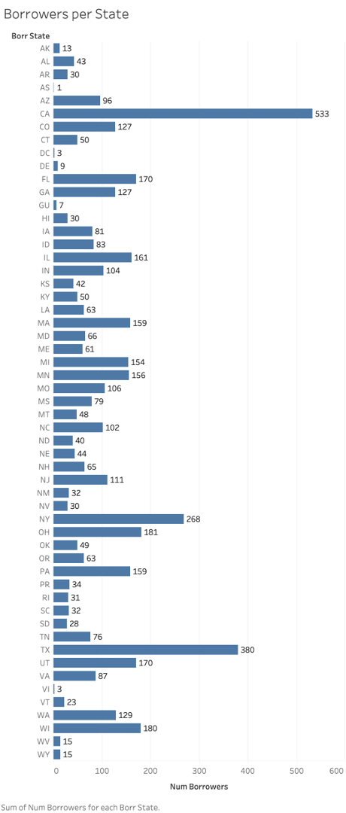

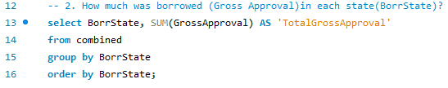

|  |  |
| --- | --- |
| BorrState | TotalGrossApproval |
| AK | 7447700 |
| AL | 12073700 |
| AR | 10637200 |
| AS | 150000 |
| AZ | 29218800 |
| CA | 1.91E+08 |
| CO | 49045700 |
| CT | 13999900 |
| DC | 976600 |
| DE | 3025200 |
| FL | 51422100 |
| GA | 56089832 |
| GU | 357500 |
| HI | 2611100 |
| IA | 30640300 |
| ID | 20491800 |
| IL | 47575500 |
| IN | 32101000 |
| KS | 10613500 |
| KY | 11654700 |
| LA | 8797200 |
| MA | 23936400 |
| MD | 13966700 |
| ME | 11913500 |
| MI | 48467000 |
| MN | 52415066 |
| MO | 24126901 |
| MS | 15708400 |
| MT | 7978600 |
| NC | 26822600 |
| ND | 9219300 |
| NE | 16180060 |
| NH | 11793100 |
| NJ | 35045300 |
| NM | 14934400 |
| NV | 6929300 |
| NY | 59831100 |
| OH | 47463800 |
| OK | 18675700 |
| OR | 14910900 |
| PA | 47263000 |
| PR | 3871166 |
| RI | 5469500 |
| SC | 9757700 |
| SD | 3234300 |
| TN | 17407000 |
| TX | 1.4E+08 |
| UT | 20800800 |
| VA | 25162200 |
| VI | 140000 |
| VT | 4672800 |
| WA | 36987976 |
| WI | 52633000 |
| WV | 3230900 |
| WY | 7285800 |

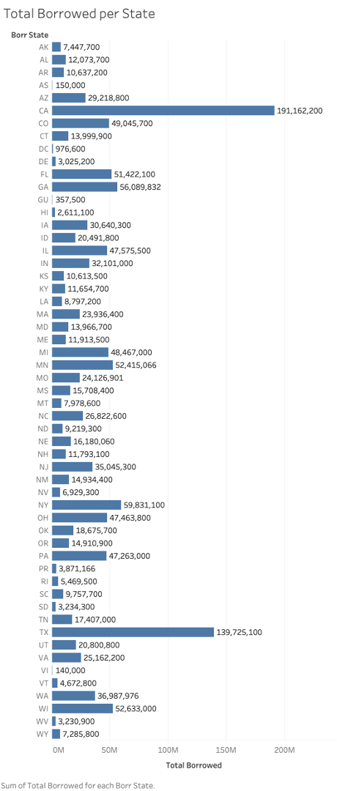

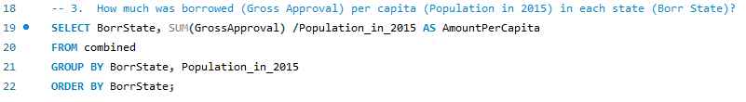

|  |  |
| --- | --- |
| BorrState | BorrowedPerCapita |
| AK | 10.0858 |
| AL | 2.4848 |
| AR | 3.5717 |
| AS | 2.7018 |
| AZ | 4.2792 |
| CA | 4.8835 |
| CO | 8.9884 |
| CT | 3.8987 |
| DC | 1.4528 |
| DE | 3.1981 |
| FL | 2.5367 |
| GA | 5.491 |
| GU | 2.2434 |
| HI | 1.8239 |
| IA | 9.8084 |
| ID | 12.3823 |
| IL | 3.6995 |
| IN | 4.8493 |
| KS | 3.6452 |
| KY | 2.6338 |
| LA | 1.8835 |
| MA | 3.5229 |
| MD | 2.3253 |
| ME | 8.962 |
| MI | 4.8845 |
| MN | 9.5481 |
| MO | 3.9658 |
| MS | 5.2495 |
| MT | 7.7241 |
| NC | 2.6708 |
| ND | 12.1799 |
| NE | 8.5329 |
| NH | 8.8629 |
| NJ | 3.9122 |
| NM | 7.1624 |
| NV | 2.397 |
| NY | 3.0224 |
| OH | 4.087 |
| OK | 4.7748 |
| OR | 3.7009 |
| PA | 3.6917 |
| PR | 1.1143 |
| RI | 5.178 |
| SC | 1.9929 |
| SD | 3.7675 |
| TN | 2.6373 |
| TX | 5.0866 |
| UT | 6.943 |
| VA | 3.0016 |
| VI | 1.3157 |
| VT | 7.464 |
| WA | 5.1585 |
| WI | 9.1197 |
| WV | 1.752 |
| WY | 12.4308 |

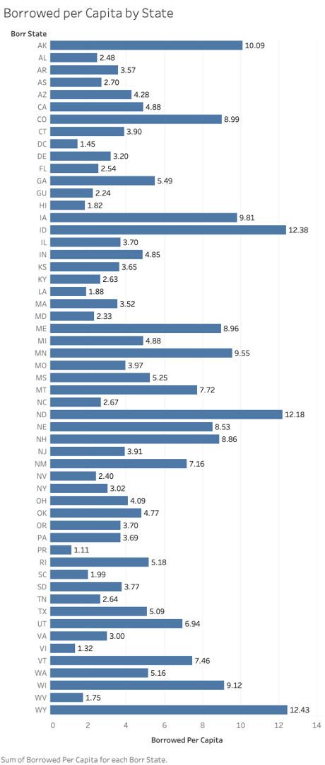

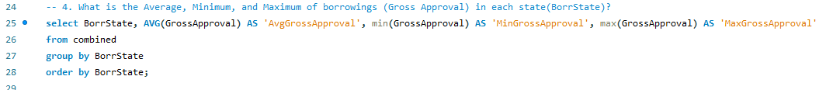

|  |  |  |  |
| --- | --- | --- | --- |
| BorrState | AvgGrossApproval | MinGrossApproval | MaxGrossApproval |
| AK | 572900 | 20000 | 1666600 |
| AL | 280783.7 | 5000 | 1750000 |
| AR | 354573.3 | 7500 | 1700000 |
| AS | 150000 | 150000 | 150000 |
| AZ | 304362.5 | 5000 | 1852000 |
| CA | 358653.3 | 5000 | 2000000 |
| CO | 386186.6 | 5000 | 2000000 |
| CT | 279998 | 10000 | 1900000 |
| DC | 325533.3 | 176000 | 556000 |
| DE | 336133.3 | 20000 | 1144200 |
| FL | 302482.9 | 5000 | 2000000 |
| GA | 441652.2 | 5000 | 1850000 |
| GU | 51071.43 | 5000 | 141000 |
| HI | 87036.67 | 5000 | 1515000 |
| IA | 378275.3 | 5000 | 2000000 |
| ID | 246889.2 | 5000 | 1555000 |
| IL | 295500 | 5000 | 2000000 |
| IN | 308663.5 | 5000 | 1800000 |
| KS | 252702.4 | 5000 | 1676000 |
| KY | 233094 | 5000 | 1434000 |
| LA | 139638.1 | 5000 | 1900000 |
| MA | 150543.4 | 2500 | 2000000 |
| MD | 211616.7 | 5000 | 1325000 |
| ME | 198558.3 | 5000 | 1660000 |
| MI | 314720.8 | 5000 | 2000000 |
| MN | 335994 | 5000 | 2000000 |
| MO | 227612.3 | 5000 | 1940000 |
| MS | 198840.5 | 5000 | 1666600 |
| MT | 166220.8 | 5000 | 1000000 |
| NC | 262966.7 | 5000 | 2000000 |
| ND | 230482.5 | 10000 | 2000000 |
| NE | 367728.6 | 5000 | 2000000 |
| NH | 181432.3 | 5000 | 1500000 |
| NJ | 315723.4 | 5000 | 1742500 |
| NM | 466700 | 9100 | 2000000 |
| NV | 230976.7 | 7500 | 858400 |
| NY | 223250.4 | 3000 | 2000000 |
| OH | 262230.9 | 5000 | 1760300 |
| OK | 381136.7 | 7500 | 1962000 |
| OR | 236681 | 5000 | 1667000 |
| PA | 297251.6 | 5000 | 2000000 |
| PR | 113857.8 | 10000 | 1050700 |
| RI | 176435.5 | 5000 | 1350000 |
| SC | 304928.1 | 5000 | 1944000 |
| SD | 115510.7 | 7000 | 670000 |
| TN | 229039.5 | 5000 | 2000000 |
| TX | 367697.6 | 5000 | 2000000 |
| UT | 122357.6 | 5000 | 1400000 |
| VA | 289220.7 | 5000 | 2000000 |
| VI | 46666.67 | 40000 | 50000 |
| VT | 203165.2 | 15000 | 712000 |
| WA | 286728.5 | 5000 | 2000000 |
| WI | 292405.6 | 5000 | 2000000 |
| WV | 215393.3 | 5000 | 1600000 |
| WY | 485720 | 15000 | 2000000 |

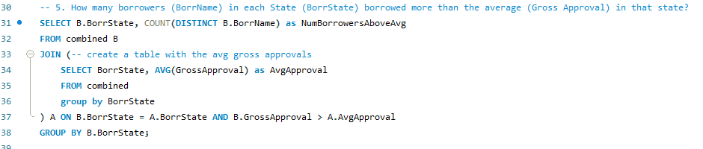

|  |  |
| --- | --- |
| BorrState | NumBorrowersAboveAvg |
| AK | 4 |
| AL | 10 |
| AR | 10 |
| AZ | 28 |
| CA | 169 |
| CO | 43 |
| CT | 13 |
| DC | 1 |
| DE | 3 |
| FL | 55 |
| GA | 47 |
| GU | 2 |
| HI | 4 |
| IA | 23 |
| ID | 23 |
| IL | 44 |
| IN | 29 |
| KS | 12 |
| KY | 14 |
| LA | 18 |
| MA | 40 |
| MD | 18 |
| ME | 14 |
| MI | 43 |
| MN | 42 |
| MO | 29 |
| MS | 26 |
| MT | 11 |
| NC | 26 |
| ND | 7 |
| NE | 14 |
| NH | 16 |
| NJ | 37 |
| NM | 9 |
| NV | 12 |
| NY | 67 |
| OH | 47 |
| OK | 15 |
| OR | 15 |
| PA | 45 |
| PR | 8 |
| RI | 8 |
| SC | 9 |
| SD | 10 |
| TN | 20 |
| TX | 116 |
| UT | 33 |
| VA | 26 |
| VI | 2 |
| VT | 5 |
| WA | 36 |
| WI | 51 |
| WV | 3 |
| WY | 3 |

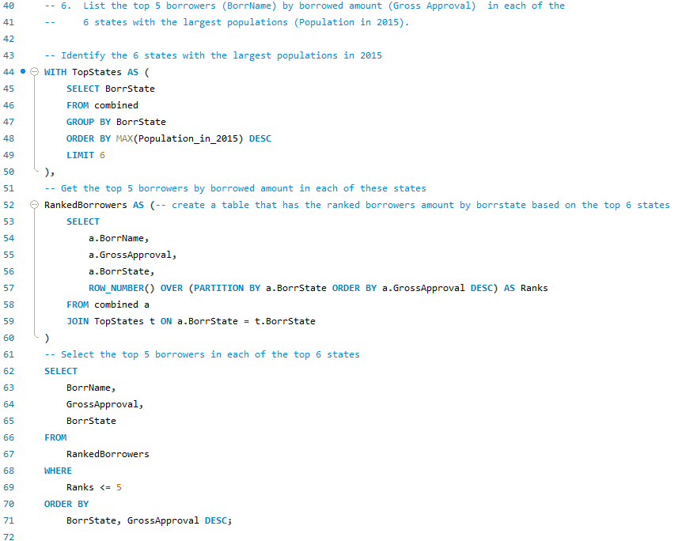

|  |  |  |
| --- | --- | --- |
| BorrName | GrossApproval | BorrState |
| Gogo Sports Inc. | 2000000 | CA |
| Four Life Foods, LLC DBA Jamba | 2000000 | CA |
| Williams Francis Hartkopf Jr D | 2000000 | CA |
| Rancho Family Medical Group, I | 2000000 | CA |
| Kiddie Academy | 2000000 | CA |
| Travelodge | 2000000 | FL |
| Michael Malerba (EPC) (EPC) & | 1742000 | FL |
| PROFORMPT | 1667000 | FL |
| Valvoline Instant Oil Change | 1658500 | FL |
| Eric W. Baxmann, DDS, P.A. & D | 1566000 | FL |
| LESAC CORPORATION & FILTER TEC | 2000000 | IL |
| Collision Centers of America, | 2000000 | IL |
| HOWE FREIGHTWAYS, INC. | 1989000 | IL |
| Plainfield Veterinary Clinic L | 1800000 | IL |
| World Class Motor Cars, Inc. | 1774000 | IL |
| PLANET KIA | 2000000 | NY |
| FRIENDS LAKE INN | 2000000 | NY |
| 455 Carroll LLC & Macro Sea In | 1900000 | NY |
| West 127 New York Inc. & Multi | 1800000 | NY |
| HUNTERS KEY LLC | 1795000 | NY |
| D2 Solutions Inc. | 2000000 | PA |
| Sander Pump Sales, Inc., Pump | 2000000 | PA |
| Dr. Curtis Baughman DBA Appleb | 1750000 | PA |
| Graphcom, Inc. | 1667000 | PA |
| Don Ann Realty LLC and Ed & Do | 1650000 | PA |
| Beltline Surgery Center LLC | 2000000 | TX |
| SUPER 8 LAPORTE, TEXAS | 2000000 | TX |
| Founders Plaza Nursing & Rehab | 2000000 | TX |
| La Quinta Inn of Balch Springs | 2000000 | TX |
| Comfort Inn | 2000000 | TX |

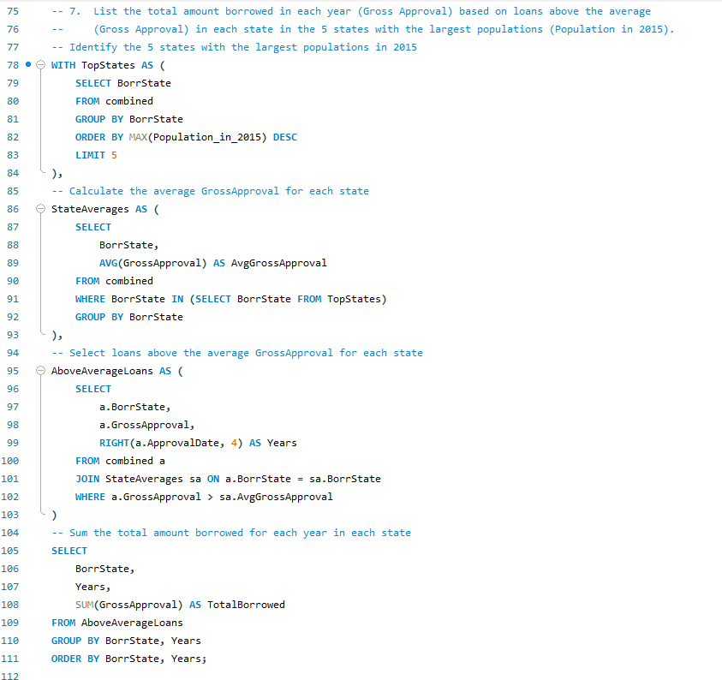

|  |  |  |
| --- | --- | --- |
| BorrState | Years | TotalBorrowed |
| CA | 2009 | 147580000 |
| FL | 2009 | 42904500 |
| IL | 2009 | 38417100 |
| NY | 2009 | 46356300 |
| TX | 2009 | 105873200 |